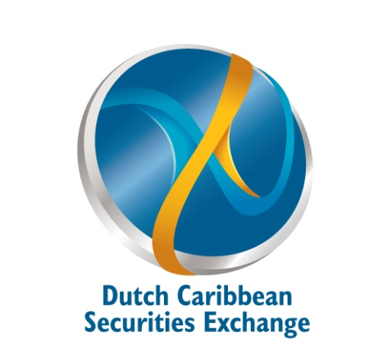

LISTING ADVISOR AGREEMENT

THIS AGREEMENT is entered this ____ day of ___, _______ between:

DUTCH CARIBBEAN SECURITIES EXCHANGE N.V.
Pareraweg 45
Willemstad, Curaçao
(Dutch Caribbean)
hereinafter referred to as “DCSX”;

company name
Address

hereinafter referred to as “Listing Advisor” or “LAD”;
WHEREAS:

(A) The DCSX is an international operating stock exchange organized under Curaçao law for the purpose of listing and trading domestic and international securities;
(B) The DCSX is licensed by the Curaçao Ministry of Finance and regulated by the Central Bank of Curaçao and Sint Maarten (Central Bank);

(C) LAD has previously been approved and recognized by the DCSX on it’s exchange in order to engage in the business of listing securities on the DCSX under the stipulations as laid out in the at any given time applicable Rules and Regulations of the DCSX and the LAD was and is as such eligible for making an application for acting as such on the DCSX ; and
(D) Whereas it was and is the right and duty of the Board of the DCSX to review and approve or disapprove such application to become a LAD,
NOW THEREFOR, IT IS HEREBY AGREED as follows:
- DCSX hereby acknowledges the application referred to above by the LAD to be recognized and approved and confirms that it has approved the LAD to act as such on the DCSX under the condition that the LAD shall at all times adhere to the at any given time applicable Rules and Regulations of the DCSX as well as to any specific Listing Advisor Requirements and/or other requirements, whether specifically applicable to LAD or not that the DCSX may at its discretion declare applicable;

- LAD declares and without reservation accepts the approval under the condition as mentioned under 1 above and declares to have read and understood the obligations as set forth in the Rules and Regulations of the DCSX, its LAD Requirements (these documents can be accessed on our website dcsx.cw) and the Ongoing Obligations for LADs Memo directive as issued by the DCSX and changed from time to time. It shall be the LADs responsibility to assure it is always in possession of the most recent applicable Rules and Regulations and/or other requirements and/or directives stipulated or issued by the DCSX.

- LAD confirms it shall at all times assure that any fees due to the DCSX are settled in time, thus assuring that it can fulfill its continuing obligations vis-à-vis the DCSX as well as the issuer for whose securities it is acting as LAD.

- LAD acknowledges that to the degree that it, or an affiliate as approved by the DCSX, is also acting as a Member/Broker on the DCSX the Member/Broker status must also be in good standing with the DCSX.

Governing Law and Jurisdiction: this Agreement shall be governed by and construed in accordance with the laws of Curaçao. DCSX and LAD agree that the courts of Curaçao are to have exclusive jurisdiction to settle any disputes which may arise out of or in connection with this Agreement and that accordingly any suit, action or proceeding arising out of or in connection with this Agreement will be brought in such courts.

IN WITNESS WHEREOF the parties hereto have executed this Agreement in threefold the day and year first above written.

DUTCH CARIBBEAN SECURITIES company name

EXCHANGE N.V.

___________________________ _______________________________________
By: By:
Title: Title:

REMAINDER OF THIS PAGE IS INTENTIONALLY LEFT BLANK

